Big Dreams. Humans. Jobs and AI.

**How to build important competencies, motivate employees and retain talent in the company in the times of crisis of loneliness, and the rise of artificial intelligence? Humanites Institute invites to participate in the largest Polish wellbeing campaign for employers!**

This May will mark the 13th edition of the "HumanBE - Two Hours for Family/Family'' campaign, organized by the Humanites Institute - Human and Technology. Over the past several years - more than **3,000 companies from 59 countries around the world** have joined this international movement for closeness, and positive changes in work culture and lifestyles, which originated in Poland. Each year the campaign is accompanied by a different theme, targeting the importance of proximity at home and at work. **The slogan for this year's edition is:** [**Big dreams bring generations together**](https://2h4family.com/campaign-motto-2024/)! **Until May 15, you can register your company and participate in this year's edition** Link to the [**registration form**](https://2h4family.com/registration-form/). **The first ambassadors of this year's campaign are** **Krzysztof Wielicki**, one of the world's most outstanding Himalayan climbers, and **Jan ("Jasiek") Mela**, a Polish traveler, motivational speaker and social activist, the youngest ever conqueror of two poles in one year.

**How to take care of talents and relationships in a hybrid corporate world?**

The campaign "Human**BE** - Two Hours for Family/Human" was initiated in 2012 in response to **global trends** such as the **crisis of ties, the decline in the sense of meaning, the phenomenon of loneliness** - in light of the needs of the **labor market, committed teams,** among others. Retaining talent, managing diversity related to gender, experience, meeting different generations (X, Y, GenZ) in the company, require a huge amount of work from management and departments responsible for building employment strategy and work culture. The quality of leadership in companies influences the shape of the work environment: **as many as 78% of people working in toxic work environments consider changing it**, while the so-called "intrinsic motivation", strongly related to purpose and the **desire to achieve a good result at work, is 30% higher in friendly work environments** - these data come from the 2nd national report of the Humanites Institute [**Well-Working - Corporate Family Responsibility**](https://www.humanites.pl/wp-content/uploads/2022/03/Raport-Well-Working-2022.pdf)[1].

According to the **Gallup Institute**, one of the biggest problems for employers in 2023[2] was the phenomenon of [**quiet quitting**](https://www.gallup.com/workplace/349484/state-of-the-global-workplace.aspx), or "quiet withdrawal" associated with low engagement, job burnout, stress, lack of meaning, among other things. Another difficulty has been the proliferation of remote and hybrid work models; **loneliness in the workplace has cost the UK economy more than** [**2.5 billion GBP a year**](https://www.vichealth.vic.gov.au/news-publications/research-publications/young-australian-loneliness-survey)**[3]**. Loneliness is a real challenge of today's world, as the data shows: it is already experienced by 36% of Europeans![4] Loneliness generates gigantic costs to be borne by companies and economies, and negatively affects our mental and physical health, sense of meaning in life and at work.

The World Economic Forum has identified loneliness as one of the greatest social challenges accompanying the technological transformation. The development of new technologies requires people to retrain and be very active in acquiring new competencies. “*Since the inception of the Humanites Institute, we have been thinking about where we are going as a society and on what foundations we want to build it, as well as how to take advantage of the opportunities brought by new technologies so that humans remain their subjects and not their objects.*" says Zofia Dzik, CEO of the Humanites Institute, the originator of the "Two Hours" campaign. “*Our mission is human and his condition in the age of technological transformation,*" she adds, "*A human who will be aware, introspective, proactive, open to learn and who will not lose his social sensitivity. The great challenge of today's world is the pace of development of new technologies, especially AI. For several years now, we have been raising the question of human subjectivity and its ability to adapt to these changes. There is a lot of talk about artificial intelligence taking over many human competencies or opportunities for business related to technologies, but an innovative business is not just an idea and the latest technologies implemented - it is still built by people and their talents: committed and motivated employees who believe in the meaning of what they do at work, want to develop and learn new things and infect others with enthusiasm.*”

It is no coincidence that the name of Poland's wellbeing campaign for employers to date includes the element "Human**BE**" - "*Because change starts with every person. Also due to the fact of the international success of our Campaign, which for several years now has been joined by employers from all continents, we decided this year to expand its name with the HumanBE element.*" - adds Katarzyna Lorenz, Director of Communications and PR of the Humanites Institute.

This year's theme: "Big dreams bring generations together" will become the theme for all the inspiring events that employers will prepare for their employees. The #HumanBE #2h4family campaign is aimed at all entities that employ people and care that the people who make up a company or institution work with a sense of meaning and well-being. Participants are encouraged to take care of relationships within the family and with loved ones as well as within the company. Research and reports by the Humanites Institute[5], as well as employer opinions, have confirmed that the broader family not only does not interfere with work, but these two pillars of human life influence each other and can positively support each other. According to the principle that "we have different lives in many roles," satisfied with private life, a happy person is also a committed employee.

The Humanites Institute was born out of a dream - to break the relationship crisis and win against the epidemic of loneliness, to make business friendly to people, families and the environment. The campaign emphasizes the importance of intergenerational exchanges, the quality of human relationships and taking care of mental health, because healthy, warm and loving relationships not only positively affect our mental and physical health, but also shape us as people and society. The fact that it's worth creating new and better business principles is attested to by the more than 3,000 entities that participate in the campaign. Among them are such recognizable companies as Unilever, Shell, Tauron, Canal+, Avon, Burda Media Polska and Signify.

Participation in the campaign provides many benefits. It influences not only the good image of the organization, but also the culture of well-being, helps build good relationships, increases awareness of the importance of employees' non-work roles[6]. It allows the company to become that change in work culture and lifestyle that Humanites wants to see in the world. Humanites' campaign is an excellent response to the **European CSRD**, which expands the scope of entities required to report their [**ESG**](https://2h4family.com/esg/) activities.

The names of the first **ambassadors of this year's campaign** are known, they are **Krzysztof Wielicki**, one of the world's most outstanding Himalayan climbers, mountaineer, mountaineering, mountaineering, the fifth man in the world to conquer the Crown of the Himalayas - 14 eight-thousand-meter peaks of the Earth, and **Jan ("Jasiek") Mela**, a Polish traveler and social activist, the youngest ever conqueror of two poles in one year, and the first person with a disability to do so; he participated in expeditions to, among others, Kilimanjaro and Elbrus. Kilimanjaro and Elbrus, among others. Ambassadors are well-known people from the world of culture, art, film, sports, science, in earlier years the campaign was supported by, among others: Andrzej Seweryn, Stanisława Celińska, Kamil Stoch, Zbigniew Wodecki. In 2024, the organizers refreshed the illustrations that have accompanied the action for years. The author of the new visual layer is Zofia Dzierżawska, an illustrator who has worked with publishers in Europe and the United States, and who has received numerous awards at the Bologna Book Fair, as well as from the Society of Illustrators in New York.

The Humanites Institute encourages employers to give employees a **symbolic two hours of free time** on International Family Day (or any other celebration day chosen by the company), which the latter can devote to nurturing relationships. This criterion is not necessary, although about 90% of registered companies make this gesture. Each year, the Humanites Institute provides [ready-made materials](https://2h4family.com/downloadable-materials/), [inspirations](https://2h4family.com/inspirations-2024/) and [ideas](https://2h4family.com/how-to-celebrate-the-international-day-of-families/) for celebrating the action.

**Partners of the action:** [Autopay](https://autopay.pl/), [Bibby Financial Services](https://www.bibbyfinancialservices.pl/), [Dell Technologies Polska](https://www.dell.com/pl-pl), [Fundacja Liderek Biznesu](https://www.fundacjaliderekbiznesu.pl/), [Great Place to Work](https://www.greatplacetowork.pl/), [Katalog marzeń](https://katalogmarzen.pl/), [Kocham Skakać](https://kochamskakac.pl/), [LIBRUS](https://portal.librus.pl/), [Lider SHE](https://lidershe.pl/), [Orange Polska](https://www.orange.pl/), [Reputacja](https://www.linkedin.com/company/reputation-managers-sp-z-o-o-/), [Storck](https://www.storck.pl/pl), [ThinkTank](https://think-tank.pl/).

**Media Partner:** [Grupa Wirtualna Polska](https://www.wp.pl/).

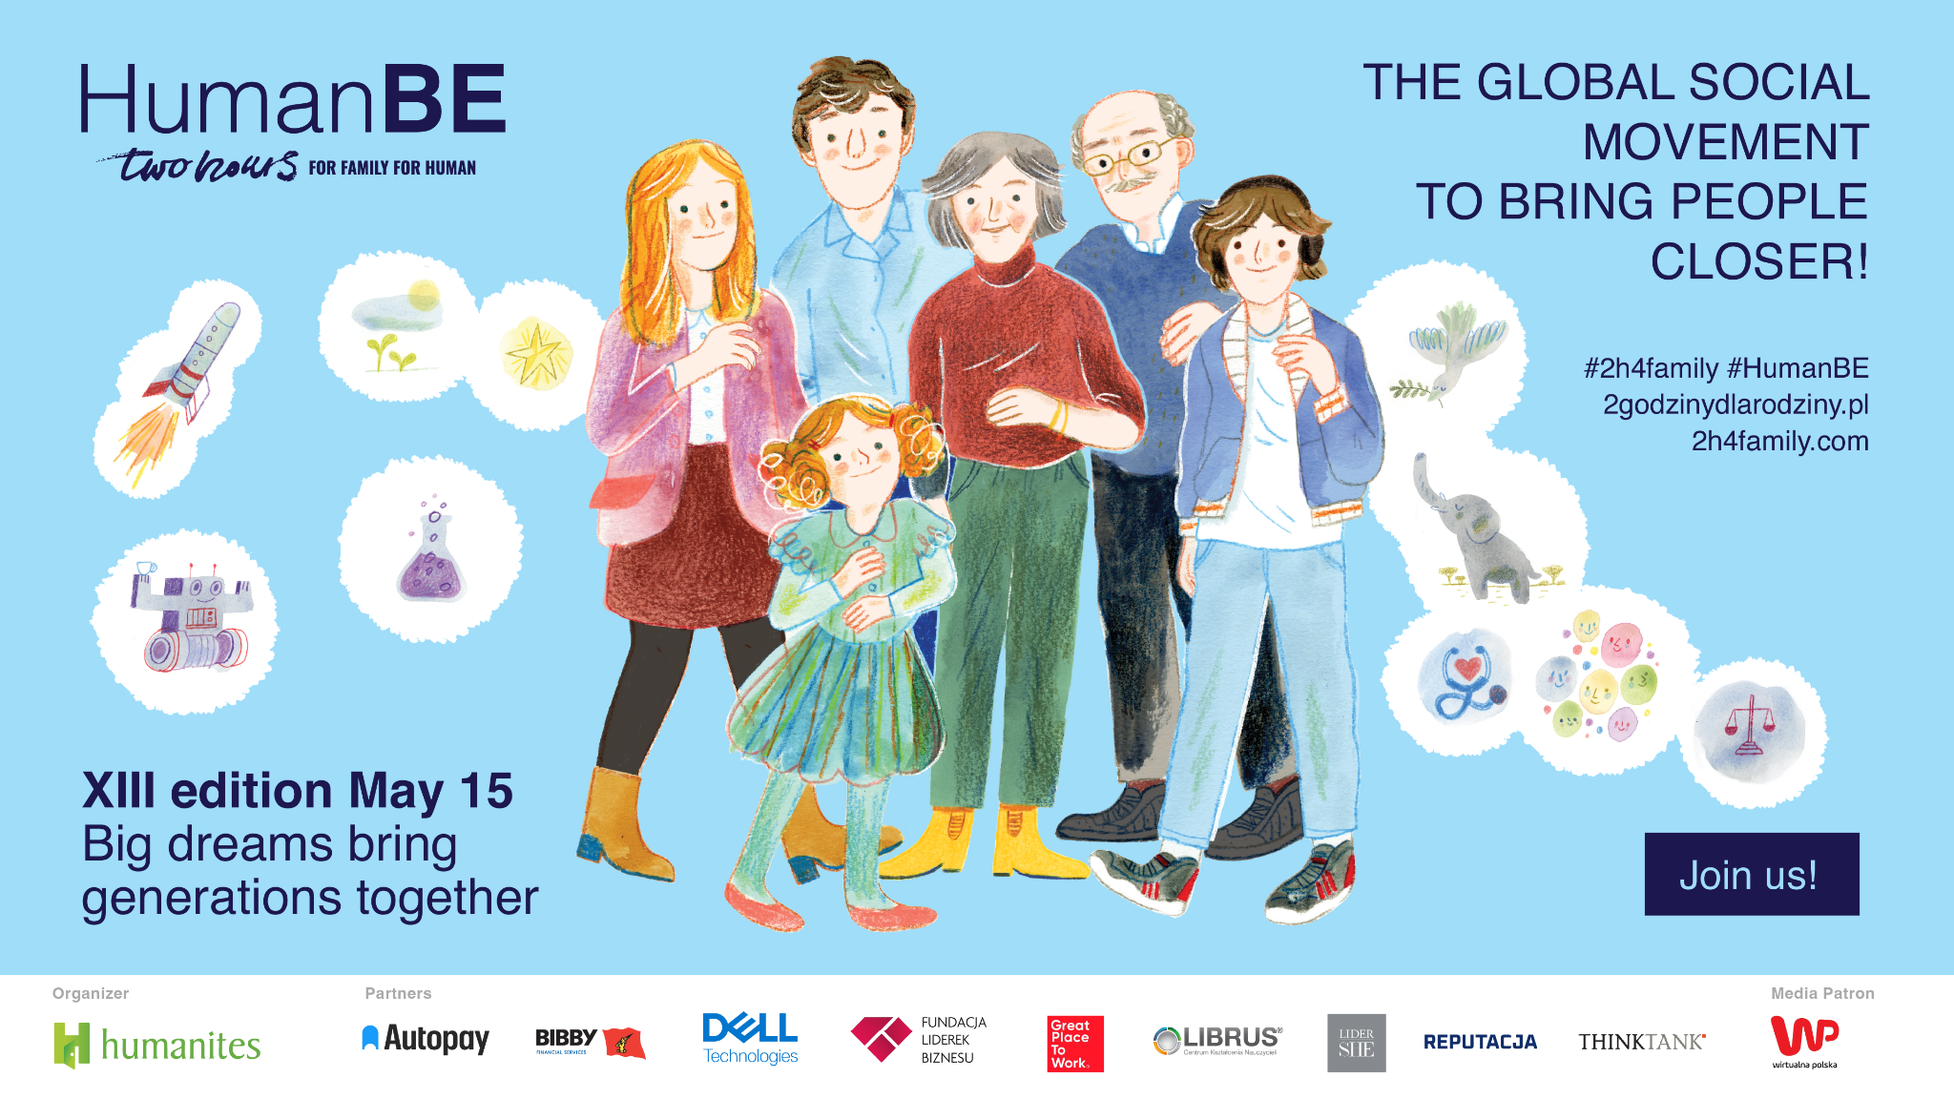

**Organizer of the Action "HumanBE - 2h4family"**

[Humanites Institute - Human and Technology](https://www.humanites.pl/en/) is a Think&Do Tank that has been working for sustainable development of social capital since 2010. The mission of the Humanites Institute is an informed, happy, cognitively open, proactive and socially sensitive human being. Humanites Institute's business programs serve companies as ready-to-implement [ESG and sustainable development projects](https://www.humanites.pl/oferta-wspolpracy/).

**Contact**: Katarzyna Lorenz, Director of Communications and PR of the Humanites Institute   
tel: +48 505 017 957, e-mail: katarzyna.lorenz@humanites.pl

Since 2010, the **Humanites Institute - Human and Technology** has been working **in a systemic way** as a **think&DO tank for sustainable development, especially the development of social capital, capturing the subject of humanity and technology in a broad context including business, education, culture, media and family**, based on its proprietary "Village" model of Social Ecosystem Development™ and the Cohesive Leadership Model™. The Institute was one of the first to signal the impact of meta-phenomena such as the crisis of family ties, loneliness, infodemia and the algorithmization of human life on people's long-term economic development, motivation and physical and mental health. For a decade, he has promoted the development of a conscious and internally controllable human being able to meet the challenges brought by the technological and social revolution. He is also the founder of the Center for Ethics of Technology. The initiator of the annual campaign "Two Hours for the Family" - Two Hours for Humanity, works for the development of key competencies through systemic change in the field of leadership in education by creating the Leadership Academy for Educational Leaders - Poland's first leadership development program in education, implements in business the idea of Cohesive Leadership™, based on the multidimensional development of the leader and his team. Organizer of annual conferences for Business Leaders: Cohesive Leadership™. Human and Technology. Humanites has been supporting the building of a high management culture for more than a decade, where business achieves its goals and people find a sense of meaning.

**HumanBE/ 2h4family** is one of the key systemic projects of the Humanites Institute, along with such projects as the #APLO Leadership Academy for Educational Leaders, the Center for Technology Ethics, and the regular conference for Business Leaders "Cohesive Leadership. People and Technology, which had its 10th edition in 2023.

1. Source:Second National Well-Working Report - Corporate Family Responsibility 2022 - Humanites Institute in collaboration with the International Center for Work and Family IESE Business School of Navarra
2. Source: Gallup Institute's 2023 State of the Global Workplace: 2023 Report
3. Source: [New Economics Foundation. The Cost of Loneliness to UK Employers, 2017](https://neweconomics.org/uploads/files/NEF_COST-OF-LONELINESS_DIGITAL-Final.pdf) 
4. [Communication from the European Commission to the European Parliament, the Council, the European Economic and Social Committee and the Committee of the Regions on a comprehensive approach to mental health](https://eur-lex.europa.eu/legal-content/PL/TXT/PDF/?uri=CELEX:52023DC0298) 
5. Humanites Institute Reports: Corporate Family Responsibility / 2022 and #Wellbeing Good Employer Practices Family&Human friendly company | Humanites 2023.
6. Based on the Humanites Institute's 2023 evaluation survey