Stay ahead of ESG trends. Social innovation from Poland counteracts loneliness globally, gives meaning to work by engaging employees from already one in three countries around the world! The 12th finale of the "Two Hours for Family/Human" is on May 15!

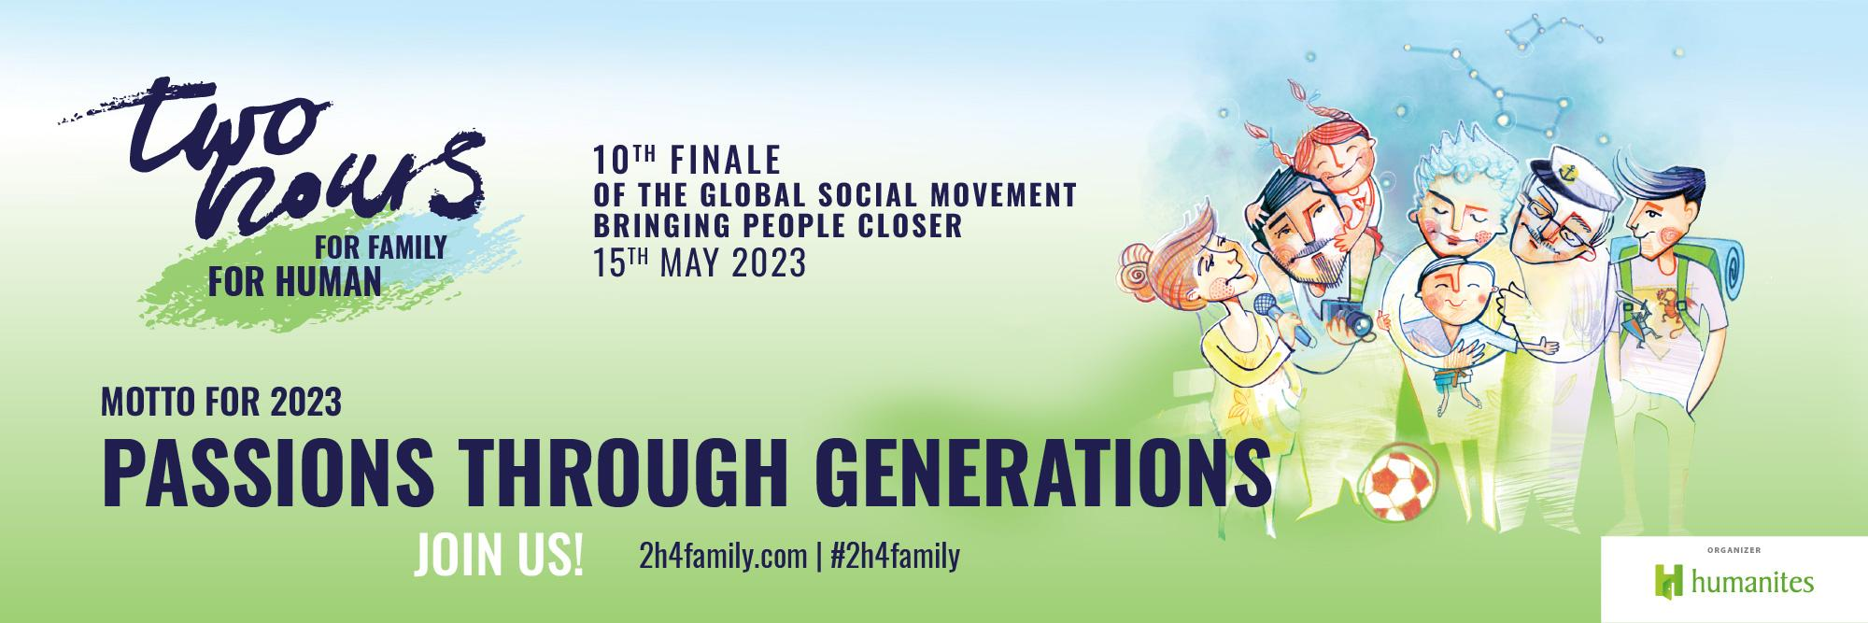

#2h4family/#4human - Humanites Institute is ahead of ESG trends in approaching social capital, with a global action for employers that counteracts the crisis of loneliness among employees in the era of hybrid work and the development of new technologies that automate work processes! 2 Hours for Family Campaign promotes a culture of well-being and cultivates good relationships in companies and high levels of work engagement. As a result it helps companies to win the battle to attract and retain talents!

Already several thousand Polish and international companies and institutions are supporting their employees by joining the "Two Hours for Family/for Human" action, which in recent years has achieved global reach reaching 59 countries around the world. The action culminates on May 15, International Day of Families.

Committed employers-participants in the action, which is authored by the Humanites Institute - Human and Technology, inspire their employees to create new rituals for building good and close relationships with their loved ones by giving them 2 hours of their working time free on this day that shall be devoted to family-bonding. This year's 12th edition of this Polish program will be held under the slogan "With Passions Across Generations."

Employers, don't delay - join the #2h4family campaign - it more than pays off!
The innovativeness of a company, in addition to its ability to combine ideas, new technologies and the market situation, depends on the team it employs: committed and motivated employees who believe in the sense of what they do at work, want to develop and learn new things, emphasizes @Zofia Dzik, a long-time entrepreneur, innovator and strategic thinker who has been combining the trends of humanism and new technologies for years as part of the Humanites Institute - Human and Technology, - and the new ESG regulations put a very strong emphasis on the responsibility - including social responsibility - of business. Therefore, more and more companies are building a competitive advantage on this, not only in terms of image, but also in terms of investors, for whom the consistency of a given company's ESG philosophy is becoming an increasingly important decision criterion.

Today, as indicated by numerous studies, many employed people are in poor mental health, which affects the quality of their duties. Generational differences and hybrid work modes have an additional negative impact on teamwork. This poses a major challenge for companies. The data speaks for itself - only 28% of employees of large companies have a high sense of meaning at work (the average result is 37%) - such data comes from the latest edition of the Humanites Institute's #WELLBEING Employer’s Good Practice Report. We are already seeing not only the phenomenon of "quiet quitting," but also a wave of absenteeism - due to reported L4. As many as 93 percent of those surveyed feel pressure to prioritize work over their private lives. Only 20 percent of male and female employees consider their supervisor(s) a role model, according to the Well-Working 2022 report. To change these negative trends, we need to inject new energy into the relationship between employers and employees.

The #2h4family/#4human movement is the answer to the global problem of loneliness, depression and relationship crisis. It counters the negative work culture in which human beings are reduced more to a resource, where respect is still one of the most missing values. The aim of the campaign is to involve business in correcting these trends, as it is a vital force of social influence. The 2h4family campaign strengthens families and teams within companies, has a positive impact on people's mental and emotional health, and ultimately acts on society as a whole by changing the culture of work and life. “The greatest value at Bibby is people," said @Tomasz Kukulski, CEO of Bibby Financial Services in Poland, "We all care about commitment and a sense of meaningful work every day. As a board, we create a friendly atmosphere full of respect for the individuality of each person, not only within the professional, but also within the family. That is why we are once again participating in the "Two Hours for the Family" initiative. This is a step towards maintaining harmony between the two areas. For us it works so well that this year we decided to become a partner of the action and encourage other companies to participate as well, especially our customers and contractors.”

The Two Hours for Family/Human action is nearly a decade ahead of the trends covered by the new CSRD. Next year, an increasing number of companies will be required to report on ESG, or Environmental, Social and Corporate Governance (ESG) activities. For many companies, the middle "S" (social) component, dealing with social impact, appears to be the least systematically taken care of and the most difficult to report on.

Society, family and work are a system of interconnected vessels
On May 15, 2023, the 12th edition of the campaign will have its finale. It has already been joined by several thousand companies that have been participating in the campaign for many years, these are both large international corporations and medium and small enterprises: including Alior Bank, Anvil, Aviva, AVON, Basf, Bank BPH, BNP Paribas, Colliers, Dohler, Enea, Enel-Med, Erbud, GFK, K2, Mostostal, Oracle, Orlen, Pentacomp, Signify, Shell, Tauron, Ultimo, Yellow, ZWAE and many others. Every year there are more and more new participants. The secret is the simplicity of the campaign - to participate, all you have to do is register your company on the website and pledge to encourage employed people around May 15 to get to know each other better within the company and spend time with loved ones, family, preferably intergenerationally. Giving time off work is not mandatory, but most companies participating in the campaign opt for this move.

The two hours donated to employees, although not mandatory, have a profound justification. Not only moral. Also purely business. The evidence? Already 14 years ago, a 6-hour work system was introduced in German Toyota dealerships, resulting in increased profits and improved productivity. An impressive example from our backyard is the Polish branch of Tradedoubler. Starting in 2019, working hours were reduced to 6 hours. This has translated into exceeding the Polish branch's key goals, including increased sales, business partner satisfaction and employee engagement. It may be counter-intuitive, but by working shorter hours, we work more and better, which looks like a dream come true for entrepreneurs - efficiency, cost-reduction and increased profits combined.

Every great change starts with one domino cube
Every year, the Humanites Institute's campaign has a motto, chosen during the competition. This year that motto is "With Passions Across Generations." Each year the Foundation prepares a number of inspirations, as well as a special card game, called ASK ME, which contains questions in the spirit of the current motto. It can be played with employees, friends or family. The ASK ME cards bring people together, inspire conversations: we will find in them a number of pretexts to ask our loved ones about their dreams, memories and passions, talk about topics that go beyond everyday questions: how it was at work, what was assigned at school, who would do the shopping.

This year's #2h4family ambassador and #2h4family ambassador had a chance to learn about the power of good questions. Actress Stanislawa Celinska recalls that her childhood passion was dancing. An intergenerational passion in her family is music. On the other hand, physicist, science journalist and popularizer of science, Tomasz Rożek, with the answer to every question, proves that his true passion is science. What would he ask a goldfish if it wanted to grant him three wishes? To be able to understand how the human brain works!

Playing ASK ME is just one of many ways to celebrate #2h4family/#4human. Companies that have joined the campaign are outdoing themselves with ideas for integration between their employees and their families. Webinars for parents, family picnics, a joint collection for an animal shelter, contests with prizes - these are just a fraction of the attractions that await employees around May 15. For those who need ready-made ideas for organizing a campaign, the Humanites Institute has prepared a range of materials and inspiration available at www.2h4family.com.

The most important thing is to move the first block. It would seem that actions such as #2h4family/4human are not much if we want a better living and working culture. This is contradicted by examples of companies that joined the campaign a few years ago with some trepidation, and then, led by the lessons learned from it, conducted evaluations among employees for the first time in their history, or hired people responsible for so-called soft HR. Humanites Institute projects, based on knowledge and research, systemically support social transformation and the place of human beings in the age of the Technological Revolution. The 2h4family action is just such a domino cube, a micro change that produces a macro effect.

More information about the campaign: www.2h4family.com
CAMPAIGN PARTNERS:
KROSS S.A., Bibby Financial Services, Great Place to Work, Fundacja Liderek Biznesu, Librus, Lider SHE, CERRAD sp. z o.o., ThinkTank, Reputation Managers, Wirtualna Polska.
COMPETITION PARTNERS:
KROSS S.A., Orange Polska, Kocham Skakać.
CONTACT:
Katarzyna Lorenz - Head of Communication and Public Relations, Humanites Institute.
e-mail: katarzyna.lorenz@humanites.pl tel.: +48 505 017 957
2h4family/4human is one of the key systemic projects of the Humanites Institute, alongside projects such as the Leadership Academy for Educational Leaders #APLO, the Centre for Technology Ethics or the regular conference for Business Leaders 'Cohesive Leadership. People and Technology, which had its 10th edition in 2023.

Since 2010, the Humanites Institute - Human and Technology has been working in a systemic way as a think&DO tank for sustainable development and especially for the development of social capital, capturing the topics of humanity and technology in a broad context including, among others, business, education, culture, media and family, based on the author's 'Village' model of Social Ecosystem Development™ and the Cohesive Leadership Model™. The Institute was one of the first to signal the impact of meta-phenomena such as the crisis of family ties, loneliness, infodemia or the algorithmisation of human life on people's long-term economic development, motivation and physical and mental health. For the past decade, he has been promoting the development of a conscious and internally controllable human being able to meet the challenges brought by the technological and social revolution. He is also the founder of the Centre for Technology Ethics. Initiator of the annual "Two Hours for the Family" campaign. - Two Hours for Humanity, works for the development of key competencies through systemic change in the field of leadership in education by creating the Academy of Leadership for Educational Leaders - the first leadership development programme in education in Poland, implements in business the idea of Cohesive Leadership™, based on the multidimensional development of a leader and his team. Organiser of the annual conference for Business Leaders: Cohesive Leadership™. People and Technology. Humanites has for more than a decade supported the building of a high management culture, where business achieves its goals and people find a sense of meaning.

