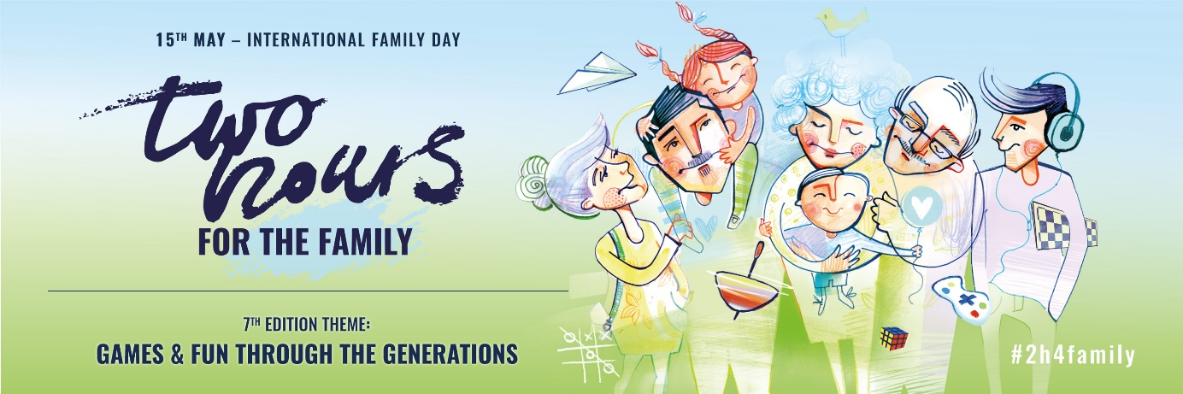

Dear Employees,

Humanites foundation together with Employers from all over Poland, and this year also from all over the world, invites you to take part in social campaign: TWO HOURS FOR THE FAMILY

Our Company has decided for the ……… time to take part in this initiative. This year, the campaign will have the following slogan:

GAMES AND FUN THROUGH THE GENERATIONS

Peter Gray once said: „Fun is something serious and unserious, trivial and deep, clever and spontaneous and, at the same time, restricted due to rules and things inherent in the real world. Fun is something childish but it is a basis for the greatest achievements of adults.”

Our company has decided to allow all of the employees to leave the workplace two hours earlier on 15th May. We believe that this time is a great opportunity to recall those moments from our lives that were full of fun, adventures, pleasures and relationships with friends. It is also an opportunity to ask our loved ones about those memories. This way we will share happiness and joy. Take a sentimental journey to your childhood. Play board games or cards. Forget about laptops, tablets, mobile phones, go to the yard, grab a skipping rope, a chalk or a ball.

[An option for the companies that have decided to buy cards for the employees]
We have prepared a gift for you – a set of ASK ME cards. It is a simple game card dedicated to families. It is a game without points, competition and losers. It is a game in which the rules are determined by curiosity of another person, his or her experiences, dreams and memories. It is our intention to help you experience closeness and joy in a new and extraordinary way.

Humanites Foundation presents generation games at its website. Take a look there and you will find ideas and inspirations (www.2h4family.com).

#2h4family
Together with the Humanites Foundation, we invite you to play and spread the idea of Campaign. Let's show what is important to us. Let us inspire others with an authentic example. Play and have fun with your family. Take a photo, mark it: #2h4family and post in your social media. In this way, not only employers show that they join the Global Social Movement but also whole families. Two Hours for the Family connect people.

We believe that this time will bring you a lot of memories and joy that you would like to share with your colleagues at work.

Sincerely,

